*Б.Когут*

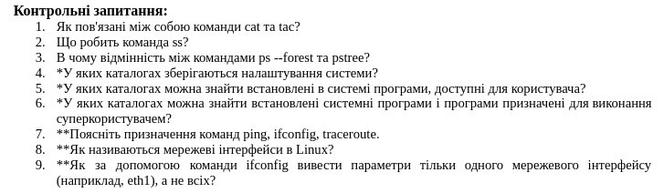**Control questions:**

1 How are the cat and tac commands related?

2 What does the ss commands do?

3 What is the difference between the ps --forest and pstree commands?

4 In which directories are system settings stored?

5 In which directories can you find the programs installed on the system and available to the user?

6 In which directories can you find installed system programs and programs designed to be executed by the superuser?

7 Explain the purpose of the ping, ifconfig, traceroute commands.

8 What are network interfaces called in Linux?

9 How to use the ifconfig command to display the parameters of only one network interface (for example, eth1), and not all?

1 The cat and tac commands are used to display the contents of a file, but the tac command displays the ile content starting from the last line to the first and command cat displays how usually from the first line to the last line.

2 The ss command is used to display socket stastistics and shows information about network connections, listening ports, and other related network info rmation.

3 The ps command displays processes in a hierachical tree format, whereas pstree is a specialized command for the same purpose but with greater visual clarity and additional features, such as showing processese with their identifires.

4 System configuration files are ypically stored in the /etc/ directory. This includes system-wide configuration files for both the operating system and installed applications.

5 User programs are ususally stored in directories like /usr/bin/, /bin/ and /usr/local/bin/. These directories contain executable files that users can run.

6 System programs and programs intended for the superuser are typically stored in directories like /sbin/, /usr/sbin/, and /usr/local/sbin/. These directories contain executables used for system administration tasks.

7 ping: This command is used to check network connectivity between two systems by sending ICMP echo requests.

ifconfig: This command is used to configure and display network interfaces, such as IP addresses and interface status.

traceroute: This command shows the path packets take to reach a specific destination, allowing you to diagnose network routing issues.

8 In Linux, network interfaces are typically named as eth0, eth1, etc., for wired Ethernet interfaces, and wlan0, wlan1, etc., for wireless network interfaces. In more modern systems, interface names may follow a more consistent naming convention like enp0s3, wlp2s0, etc.

9 To display the parameters of a specific network interface, such as eth1, you can use the following command:  
 ifconfig eth1